# ABC’s Inventory Management System

## Test Script

|  |  |  |  |  |  |
| --- | --- | --- | --- | --- | --- |
| **Test Name** | | Test output when both Product Code and Product Item Code field are filled to search for a product. (Test Case SPT006) | | | |
| **Use Case Tested** | | Search Product | | | |
| **Test Description** | | This test tests the outcome of clicking on the searching for a product by entering both product code and product item code field. | | | |
| **Pre-Conditions** | | Meta data must exist. | | | |
| **Post-Conditions** | | Appropriate message is displayed. | | | |
| **Notes** | | Product code and product item code entered may or may not exist in the database. | | | |
| **Result (Pass/Fail/Warning/ Incomplete)** | | Pass | | | |
|  | **Test Step** | | **Expected Test Results** | **P** | **F** |
| 1. | Open the ABCInventoryClient.exe file | | ABCInventoryClient system launches. | P |  |
| 2. | Enter Product Code in the product code field. | | System waits for user to hit the ‘Search’ button. | P |  |
| 3. | Enter Product Item code in the product item code field. | | System waits for user to hit the ‘Search’ button. | P |  |
| 4. | User enters the ‘Search’ button. | | System displays a message notifying the user not to enter product code and product item code at the same time for searching. | P |  |

|  |  |  |  |
| --- | --- | --- | --- |
| **Test Data Table** | | | |
|  | **1** | **2** | **3** |
| **Product Code** | S1 | S3 | RT43 |
| **Location ID** | S1100 | S3200 | RT43501 |

# Result Screenshots

The screenshots of the result on each test step for each data set are given below:

## Data Set 1

**Step 1**

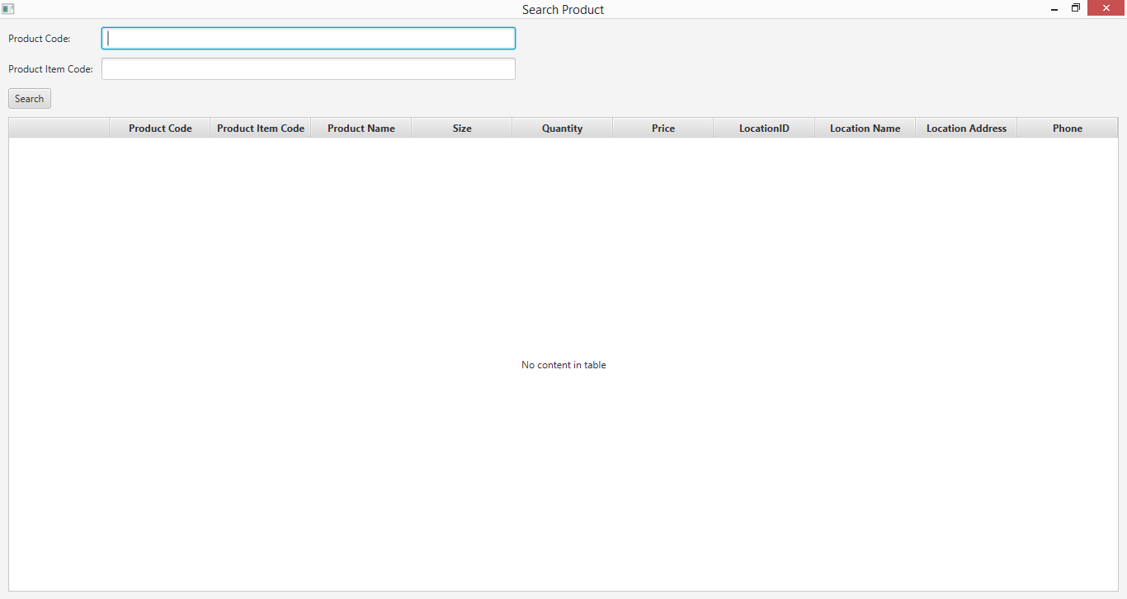

**Step 2**

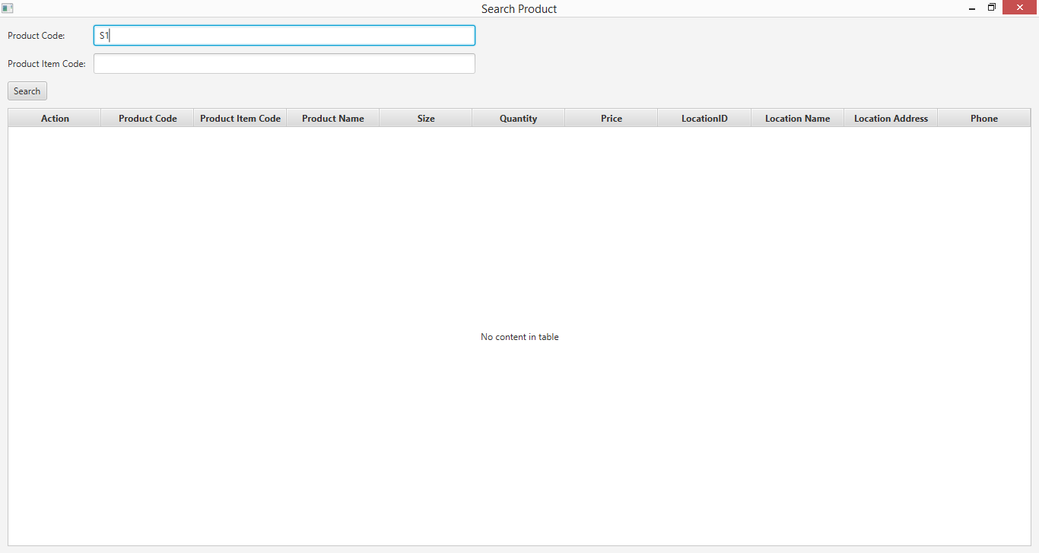

**Step 3**

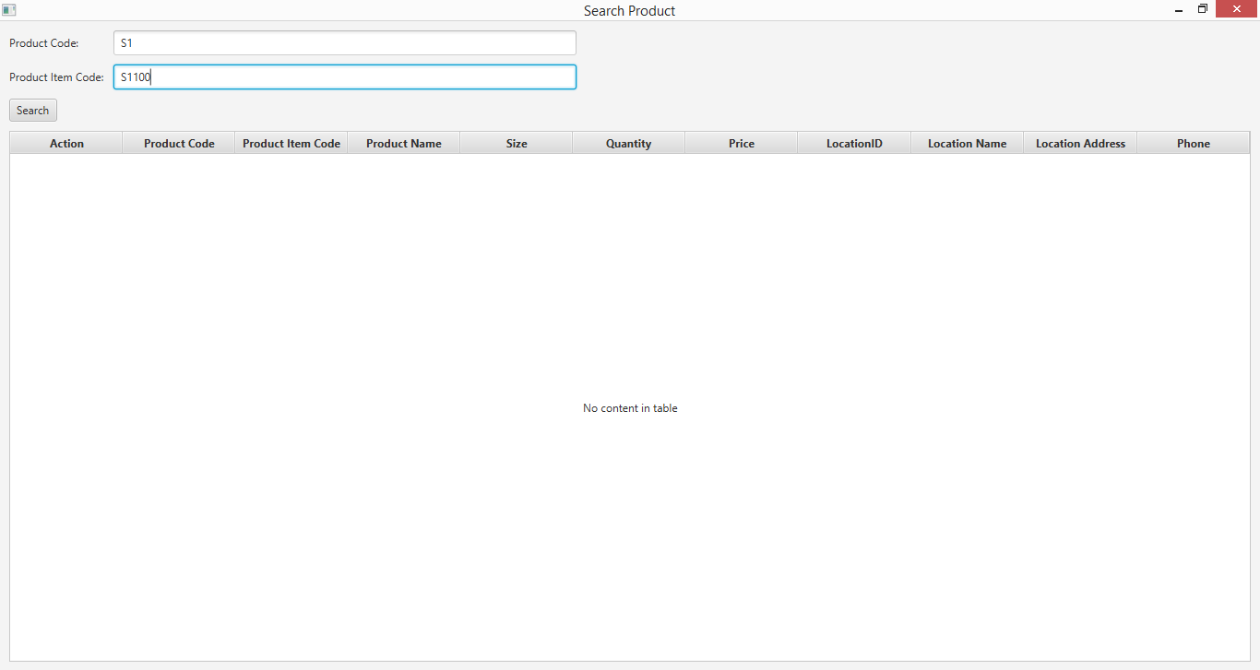

**Step 4**

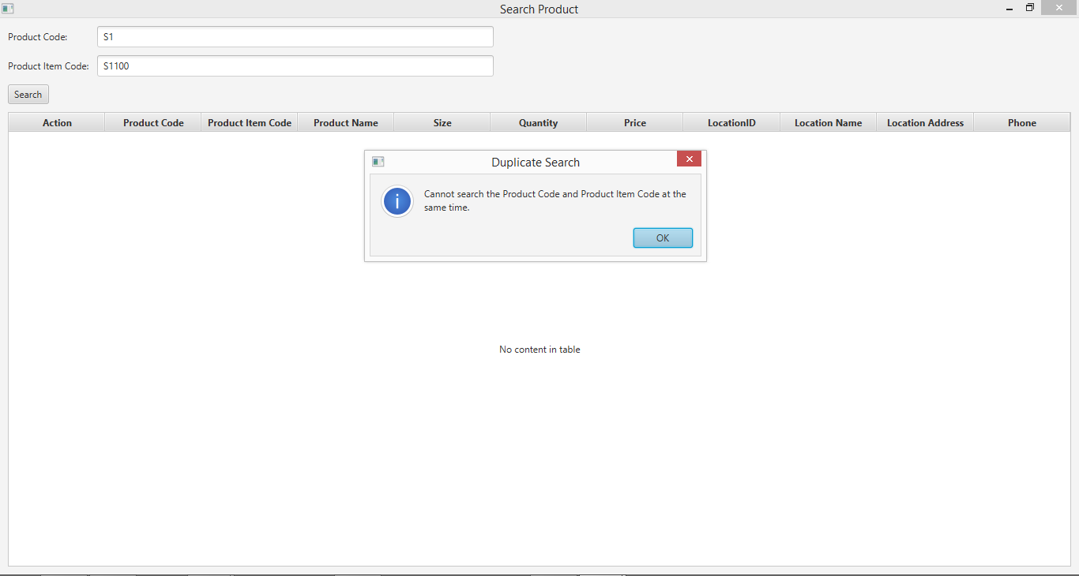

## Data Set 2

**Step 1**



**Step 2**

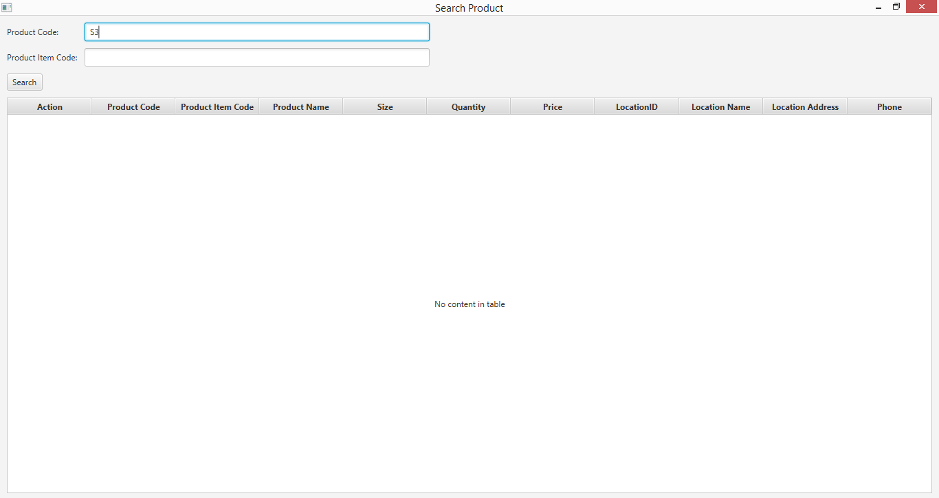

**Step 3**

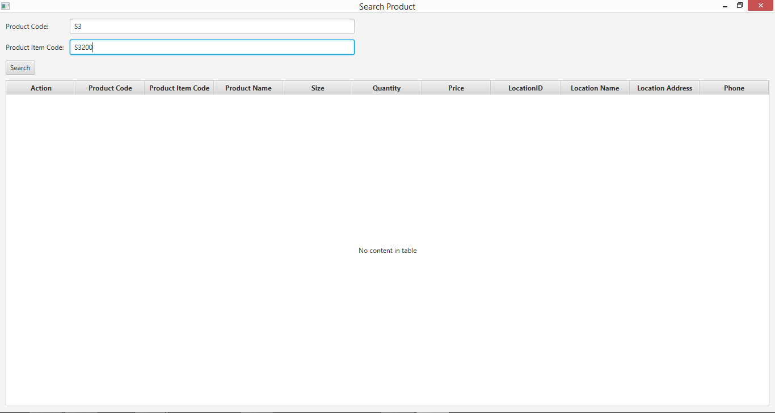

**Step 4**

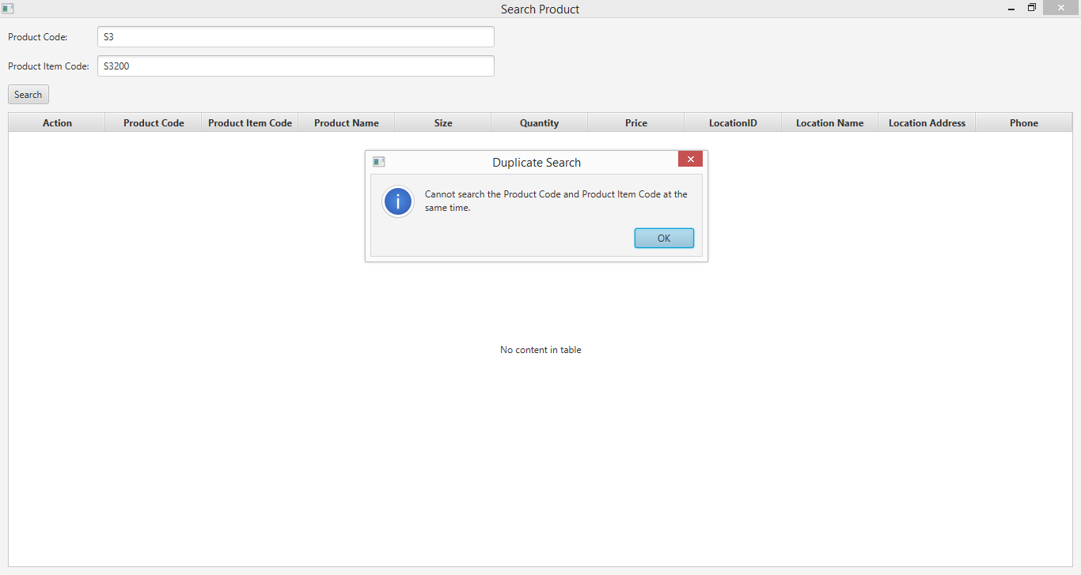

## Data Set 3

**Step 1**



**Step 2**

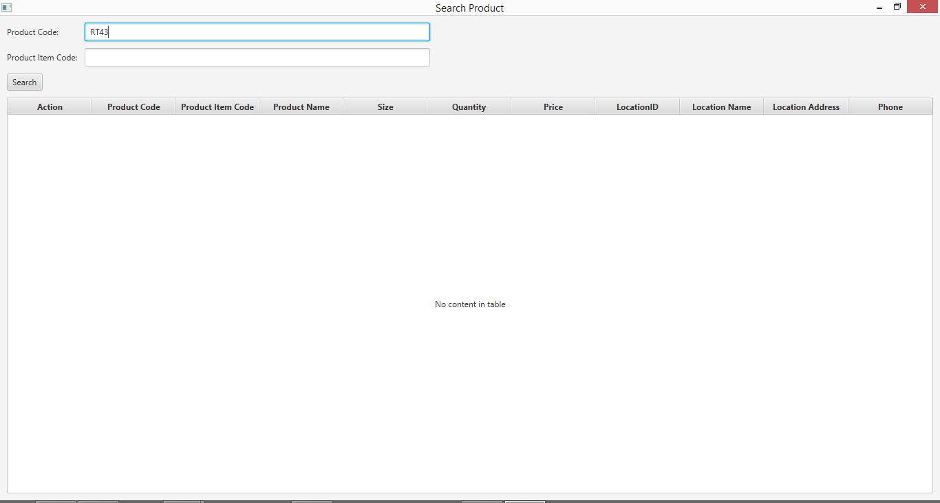

**Step 3**

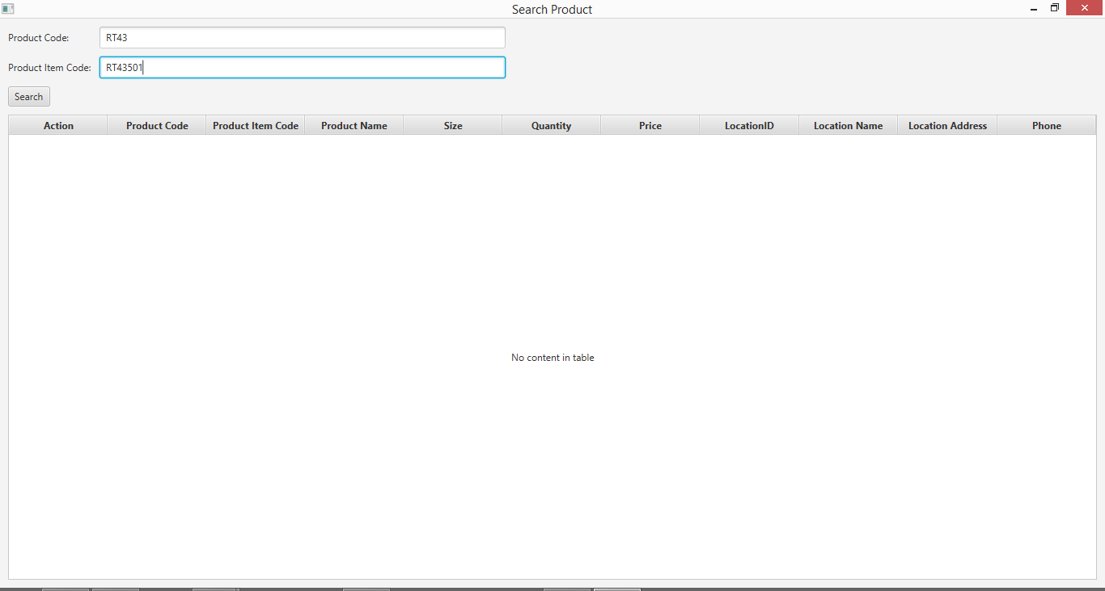

**Step 4**

